# Adding 2 Bits

## Understanding the Problem:

Consider two bits 0, 1 and add them together in all possible combinations.

a -> 0 0 1 1

b ->0 0 0 1 0 0 1 1

s -> 0 1 1 0

In decimal: 2 3

41 8

1

The one in the units column of the answer is the half sum, and the 1 that is brought over is called the carry out (subscript on the 4).

In binary there's always a half sum (s) and a carry out, which is in blue above. In each column you add three things, the carry in (which was the carry out from the column before), and the two numbers.

## Putting the Info into the Form of 2 Truth Tables

|  |  |  |
| --- | --- | --- |
| a | b | s |
| 0 | 0 | 0 |
| 0 | 1 | 1 |
| 1 | 0 | 1 |
| 1 | 1 | 0 |

|  |  |  |
| --- | --- | --- |
| a | b | carry |
| 0 | 0 | 0 |
| 0 | 1 | 0 |
| 1 | 0 | 0 |
| 1 | 1 | 1 |

These truth tables are XOR (for the half sum) and AND (for the carry).

So adding a to b can be done with logic gates:

sum = a XOR b  
carry = a.b

## So What Does the Circuit Look Like?

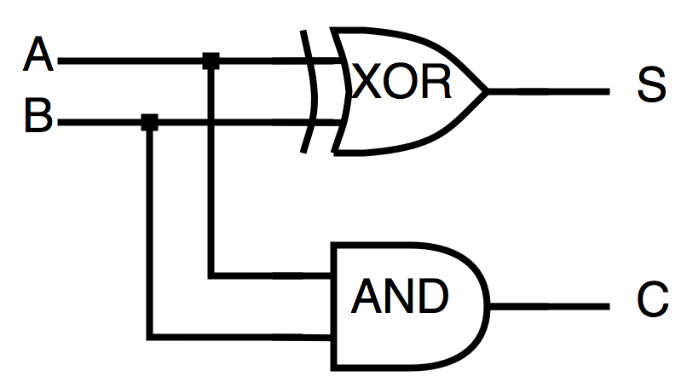

Where S is the half-sum and C is the carry-out.

He showed us a program called Multimedia Logic which we can use to construct logical circuits and test them.

# Looking More Closely at the "Carry" Process

## Decimal Example:

0 7 9 6  
01 21 41 80  
1 0 4 4

So each time we're adding 3 things, the two digits and the carry-in. Have to do this if we want to do multi-digit addition.

From this we get two outputs, the sum and the carry-out.

The carry-out becomes the carry-in for the next addition.

carry-out <- |a| <- carry-in

|b|

|

sum

This component (the attempted drawing) is called a Full Adder.

We can combine full-adders to make multi-digit adders, connecting the carry-out from each to the carry-in from the next.

(There were a lot of diagrams around here, so I'm missing a lot)

The carry ripples through the circuit and so the circuit is called a ripple-carry adder.

There are alternatives to a ripple-carry adder that are faster (each digit addition has to wait for the one before it to finish), but this is the simplest.

For the labs: He wants us to keep careful notes on each lab, and a log of the labs you've done.